Project Manager Guide

for CA PPM Users

**Table of Contents**

Document Change Record 3

Document Purpose 4

Other, Related Documents 4

Introduction 5

Project Summary 5

Useful links: 5

1. Overview Page and Dashboards 6

1.1. General Tab 6

1.2. PM Alerts Tab 7

1.3. Project Dashboard Tab 8

1.4. Issues and Risks Tab 8

2. Managing Projects 10

2.1. Project List 10

2.1.1. Filtering the Project List 10

2.1.2. Saving a Project Filter 11

2.2. Viewing Project Properties 12

2.2.1. Updating Project Progress 13

2.2.2. Assessing the Project’s Risk 15

2.2.3. Changing the Project Stage 15

2.2.4. Adding a Project to My Projects Portlet 16

2.3. Reporting Project Status 17

2.3.1. Creating a new Status Report 18

2.3.2. Copying a Status Report 19

2.3.3. Publishing a Status Report 20

2.4. Team Management 21

2.4.1. Adding Resources to the Project 22

2.4.2. Allocating Hours to a Resource or Role 22

2.5. Managing Milestones (Optional) 23

2.5.1. Creating a Milestone 23

2.5.2. Setting Key Task or Milestone Progress 24

3. Project Risk, Issue, Change Request Management 26

3.1. Risk Management 26

3.1.1. Creating a New Risk 27

3.1.2. Document a Risk Response 28

3.2. Issue Management 28

3.2.1. Creating a New Issue 29

3.2.2. Create an Issue from a Risk 29

3.3. Change Request Management 30

3.3.1. Creating a New Change Request 30

4. Running Reports 32

4.1. Running a Report on a Project Instance 32

4.2. Running a Report 32

5. Available Reports 35

5.1. KPIs by Project Type 35

5.2. Project Change Request Register 36

5.3. Project Issue Register 37

5.4. Project List 38

5.5. Project Risk, Issue, and Change Summary 39

5.6. Project Risk Register 41

5.7. Project Status Detail 42

5.8. Project Status Report List 43

5.9. Project Status Summary 44

5.10. Project Storyboard 45

# Document Change Record

|  |  |  |  |
| --- | --- | --- | --- |
| Version | Date | Editor | Description |
| 3.1 | 2017/11/14 | R. Redding | Replaced “Clarity” with CA PPM where applicable |
| 3.1 | 2015/11/10 | W. Lloyd | Document format revisions |
| 3.0 | 2015/09/04 | T. Parkin | Screen example revisions |
| 2.0 | 2015/01/22 | T. Parkin | Wording revisions |
| 1.0 | 2014/11/19 | M. Cheung | Original edition |

# Document Purpose

The purpose of this document is to provide an overview of the core functions available to users with Project Manager capabilities within the CA PPM application.

Additional application functionality, and from that user profile privileges, will be implemented over time. Supplemental Guides will be developed and released as required. The general concepts in this document of the User Interface and data entered should form a good foundation for those with Inquiry-Only privileges.

# Other, Related Documents

A selection of other documents is located on the PPM SharePoint site <https://sharecio.gov.bc.ca/asb/PPM/default.aspx>. New materials are being added to this site on an on-going basis.

# Introduction

This document is intended for project managers within the OCIO of the Government of British Columbia. This document provides a walkthrough of the functionality available to the Project Managers.

## Project Summary

Technology Solutions determined that there was a business need for a single source of project information. The current state of project portfolio tracking is managed in a siloed environment using various software programs with no integrated/shared information reporting structure. The goal of this proof of concept is to create a single source that service delivery units can go to for financial/executive reporting and provide a LEAN process that will assist in avoiding duplication of input, so that resources can better manage their project portfolios.

The implementation of CA PPM had the objective to organize, automate and synchronize business processes, as well as standardize, streamline and improve the life cycle of project portfolio management.

## Useful links:

PPM Training and Development site: <https://cppm9010-dev.ondemand.ca.com/>

PPM Production site: <https://cppm9010.ondemand.ca.com/>

PPM SharePoint: <https://sharecio.gov.bc.ca/asb/PPM/default.aspx>

1. Overview Page and Dashboards

Users are presented with the Overview page upon accessing CA PPM. The overview page provides a number of tabs a project manager can use to review and manage information within PPM:

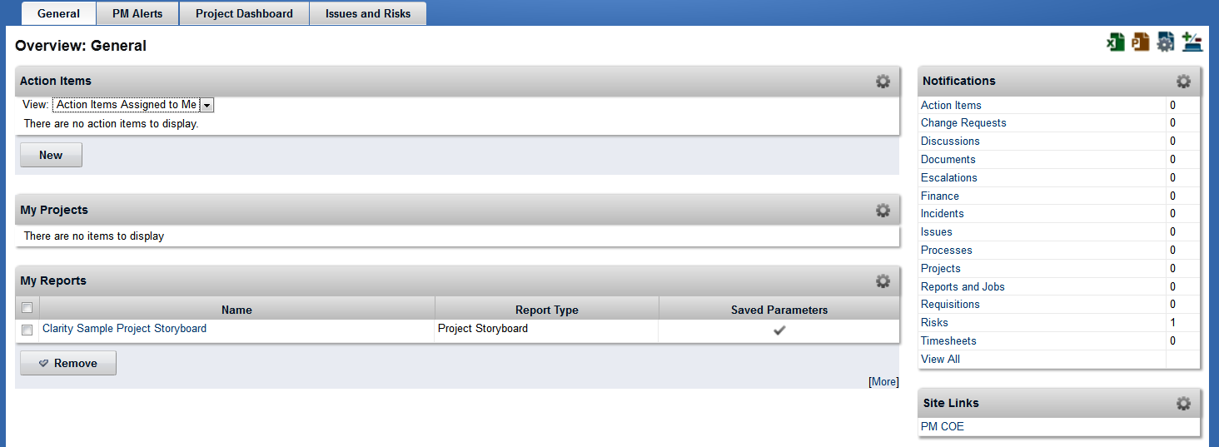

* 1. General Tab

The General tab provides easy access to commonly accessed portions of CA PPM:

| **Portlet** | **Description** |
| --- | --- |
| **Actions Items** | Action Items are nontasks that you assign to yourself, or others assign to you. You can use action items to track the progress of projects and to help ensure that a project is complete and on time.  You can create both personal and project-related action items. You create personal action items from the Organizer page and project-related action items from within a project. The Action Items tab on the Organizer page lists all of the personal and project-specific action items that you create. The Action Items tab also lists action items that others create and assign to you. |
| **My Projects** | Use this portlet to view your favorite projects. |
| **My Reports** | Use this portlet to store your favorite reports. You can also save your own personal parameters so that the report output aligns with your expectations. |
| **Notifications** | Use this portlet to view a summary count of notifications sent to you by category. Categories include Action Items, Change Requests, Discussions, Escalations, Finance, Timesheets, and other functional areas. Click a category to view more details about the notifications. You can configure this portlet to receive notifications by application alerts, email, or SMS text messages. |
| **Site Links** | Use this portlet to view the number of unstaffed ETC hours by project. The hours represent tasks with a known role but no assigned resource. You can filter the data by OBS or Project Manager and adjust the range of days (Days Outlook) from a starting point (As Of Date). |

* 1. PM Alerts Tab

**TIP:** Some pages provide page level filters that will filter against all portlets on the page.

**TIP:** Get quick access to your projects or reports by adding them to the My Projects or My Reports portlets. See how later on in this document.

The PM Alerts tab provides an “at-a-glance” view of the upcoming events on the projects a project manager has access to

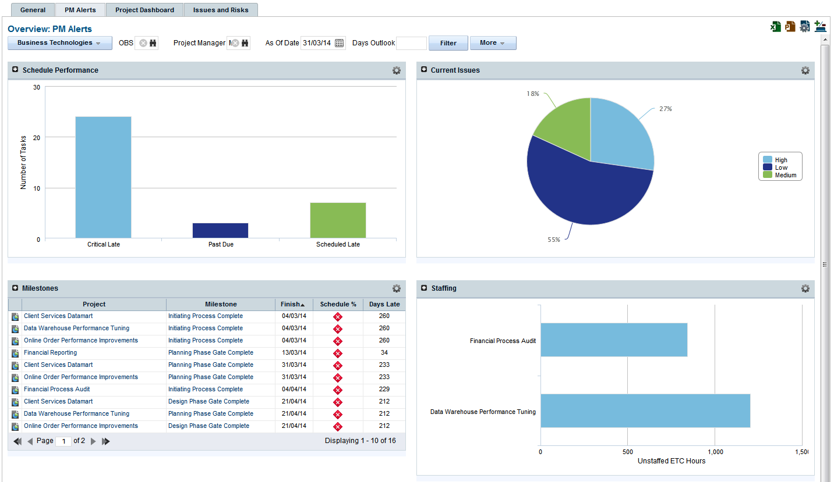

| **Portlet** | **Description** |
| --- | --- |
| **Schedule Performance** | Use this portlet to view the number of tasks categorized as critical late, past due, scheduled late, or on schedule. You can filter the data by OBS or Project Manager and adjust the range of days (Days Outlook) from a starting point (As of Date).  The Schedule Performance portlet displays the number of late tasks categorized as critical late, past due, or scheduled late within the next 45 days (default) or number of days entered in the Days Outlook filter. Portlet filters include: OBS, Manager, As of Date, and Days Outlook. |
| **Current Issues** | Use this portlet to view the number or percentage of issues grouped by priority in a pie chart. You can filter the data by OBS or Project Manager and adjust the range of days (Days Outlook) from a starting point (As of Date). |
| **Milestones** | Use this portlet to view a list of projects and milestones including their planned finish date, schedule percent complete, and cumulative days late. You can filter the data by OBS or Project Manager and adjust the range of days (Days Outlook) from a starting point (As of Date). |
| **Staffing** | Use this portlet to view the number of unstaffed ETC hours by project. The hours represent tasks with a known role but no assigned resource. You can filter the data by OBS or Project Manager and adjust the range of days (Days Outlook) from a starting point (As Of Date). |

* 1. Project Dashboard Tab

**TIP:** To toggle between portlets that are collapsed, use the down-arrow next to the portlet name.

The project dashboard provides an overview of the current projects. The portlets on this page can be collapsed together or displayed separately:

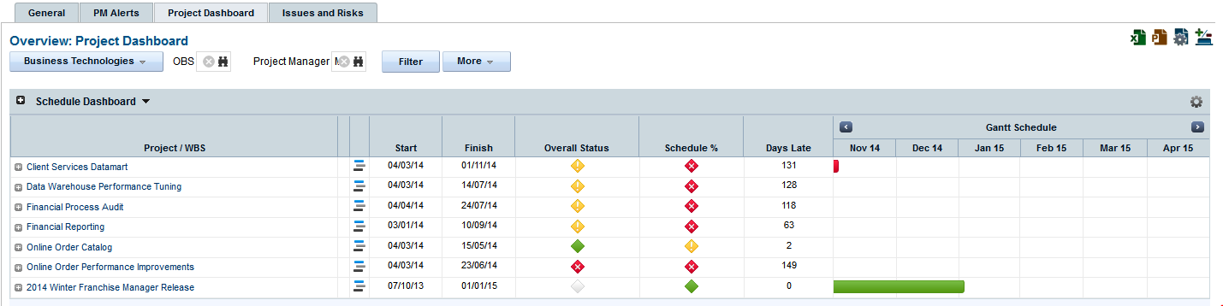

| **Portlet** | **Description** |
| --- | --- |
| **Schedule Dashboard** | Schedule Dashboard displays project schedule performance and a Gantt |
| **Cost and Effort Dashboard** | Cost and Effort Dashboard displays project cost and effort performance amounts and variances |

* 1. Issues and Risks Tab

The issues and risks tab provides a summary of the issues and risks on the projects a PM manages. The portlets on this page can be collapsed together or displayed separately:

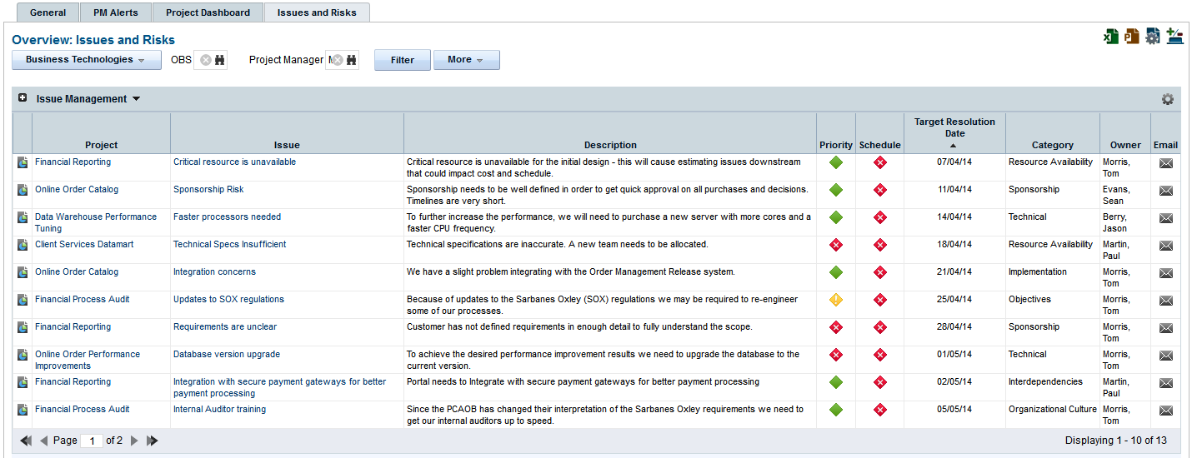

| **Portlet** | **Description** |
| --- | --- |
| **Issues Management** | Use this portlet to view a list of issues, including risk items, by project. Default columns display the priority, schedule impact, category, owner, and resolution date. You can click the envelope icon in the Email column to send mail to the owner of the issue. Click an issue to open it. You can filter the data by OBS or Project Manager. |
| **Risk Management** | Risk Management displays a list of risks associated to projects. |

**TIP:** On a page filter, use the **More** button to control how data is filtered on the page, including Show All and Save Filter.

Saved filters can be applied the page (if they exist) with a click of the button.

1. Managing Projects
   1. Project List

To review a list of projects you have access to, select Home 🡪 Portfolio Management 🡪 Projects

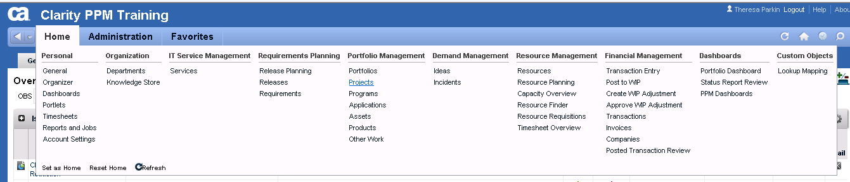

By default, project managers will see all active projects in the department.

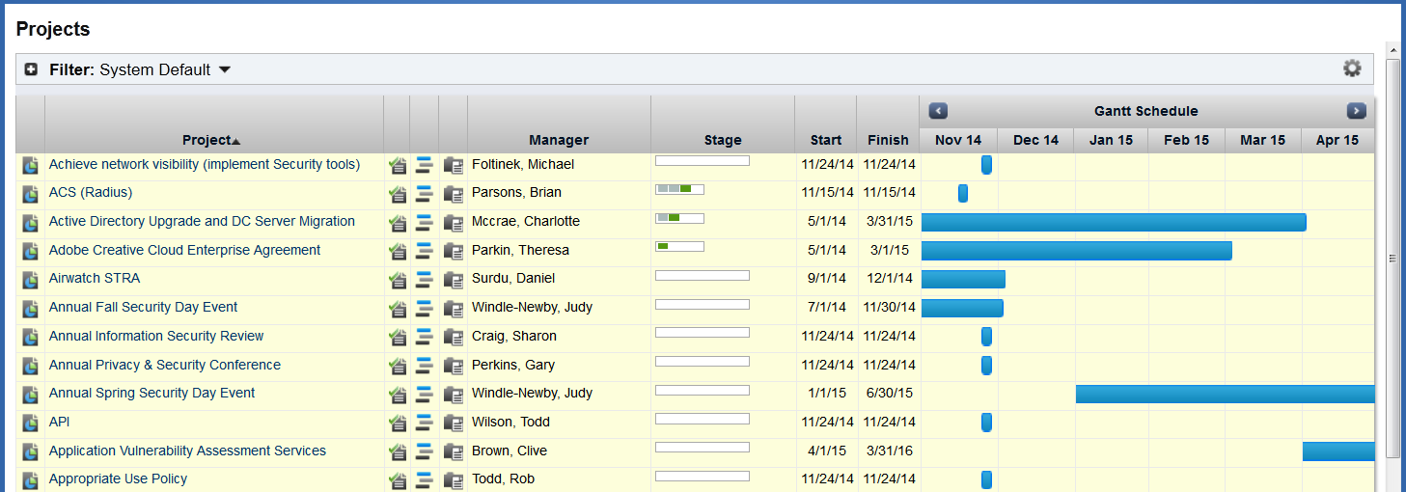

* + 1. Filtering the Project List

1. Open the project listing;
2. Expand the filter section by clicking on the + icon ();

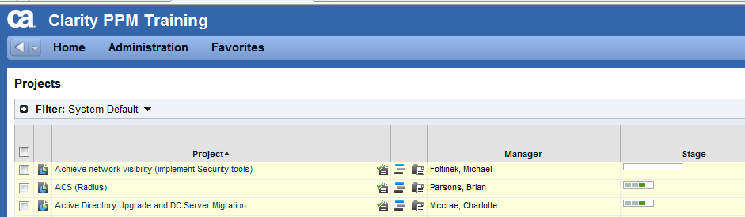

1. Build the desired filter (see tips below for some suggestions);
2. Click on the “Filter” button to filter the list of projects.

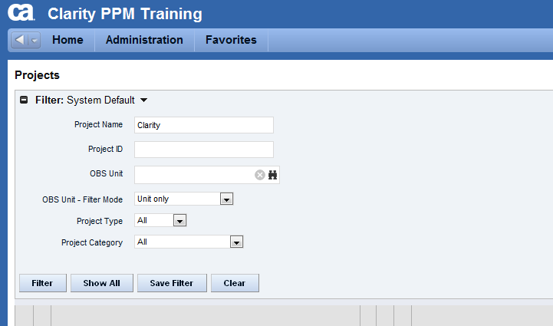

* + 1. Saving a Project Filter

1. Open the project listing;
2. Create a filter;
3. Click on the “Save Filter”;



1. Provide the filter a relevant name;
2. If “Default” selected, the filter will apply when the project listing is selected.

**TIP:** Projects have been assigned to the appropriate departments. The hierarchical structure of the OBS (organizational breakdown structure) can be leveraged to select all projects along a department’s branch. For example, with the Project filter open:

1. Click on the binocular icon next to “OBS Unit”;
2. Browse through the department structure, select a department;
3. Use the “OBS Unit – Filter Mode” dropdown to select how to filter the OBS;
4. Options include “Unit Only”, “Unit and Descendants”, “Unit and Ancestor”;
5. Save the filter to have easy access to these projects.
   1. Viewing Project Properties

**TIP:** Remember to save changes to the properties page before navigating to another section.

To review a list of projects you have access to, select the name of the project to view the project properties

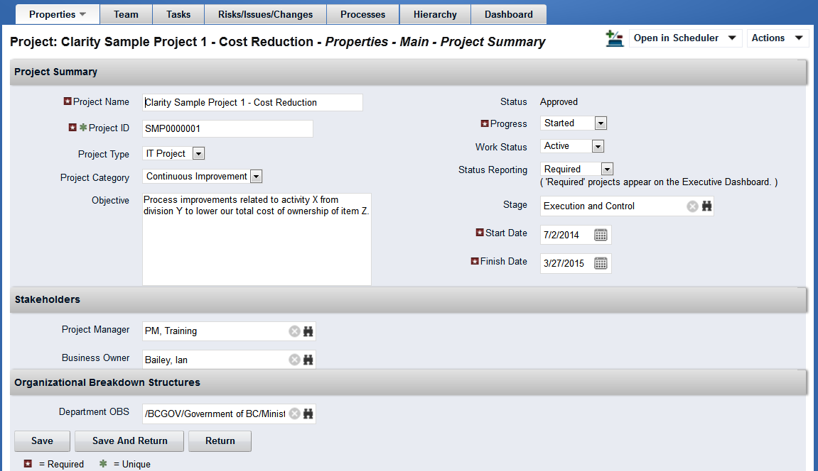

The project properties pages can be accessed using the down arrow next to the tab name. Project properties are divided into 4 main sections:

| **Section** | **Description** |
| --- | --- |
| **Project Summary** | Provides the basic project information including Name, objective, project type and category, progress, work status, start and finish dates and stage. This section also lists the key stakeholders of the project and the department the project belongs to. |
| **Schedule & Performance** | Provides an overview of the project performance. Use this page to update the % Complete of the project. |
| **Business Alignment** | Provides an indicator of how well the project will fit with the organization’s goals. This data will be important when comparing the value of different projects. |
| **Risk Rating** | High-Level assessment of the project’s risk along 11 categories. Each category is assessed on a High-Medium-Low scales and the project’s overall risk is calculated. |

* + 1. Updating Project Progress

1. Open the project;
2. Select the down arrow next to Properties;
3. Select “Schedule & Performance”;

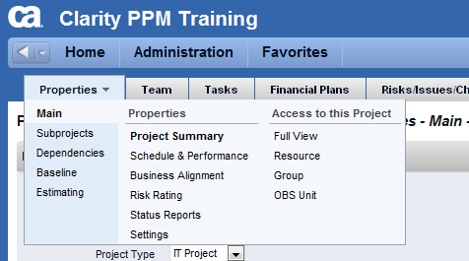

1. Enter the project’s “% Complete”;
2. Update the “As of Date” to indicate when this progress applies.
3. Click on “Save” to save changes.

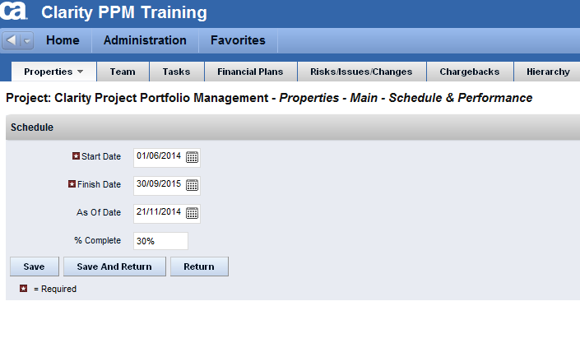

**TIP:** If project tasks are being used, the project’s overall progress can be calculated based on the progress on the tasks.

* + 1. Assessing the Project’s Risk

1. Open the project;
2. Select the down arrow next to Properties;
3. Select “Risk Rating”;



1. For each of the 11 categories, provide a high-level assessment of the riskiness of the project;
2. Click on “Save” to save changes.

**TIP:** If a risk category is read-only, an actual risk corresponding to that category has been created. The project’s risk rating for that category is the amalgamation of all open risks belonging to that category.

* + 1. Changing the Project Stage

1. Open the project;
2. Select the binoculars next to the “Stage”;

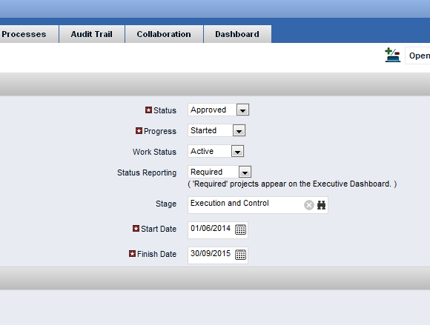

1. Click on the + next to “IT”;
2. Select the stage you wish to transition to;
3. Click on “Add”;
4. Click on “Save” to save the change.

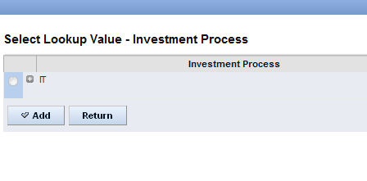

* + 1. Adding a Project to My Projects Portlet

1. Open the project;
2. On the left hand side of the screen, click on “Actions”;

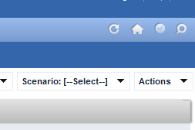

1. Under “General” select “Add to My Projects”.

**TIP:** The “General” actions menu contains links to pages where you can track personal Notes or URLs specific to the project. The information entered here is not available to other users.

* 1. Reporting Project Status

The status of the project is to be reported on a biweekly basis. CA PPM’s status report will be the key mechanism for communicating issues to management.

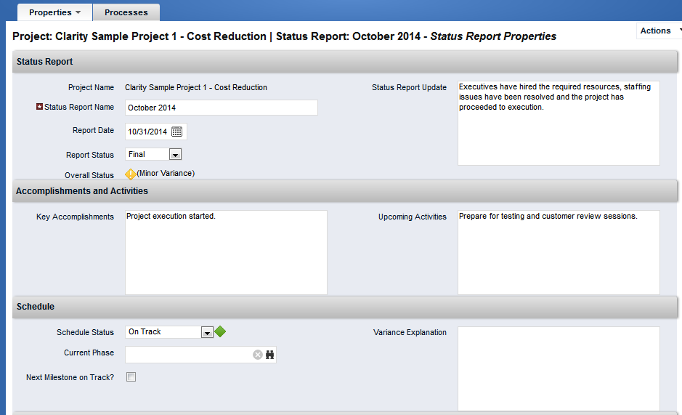

Status reports are based on 3 project KPIs: Schedule, Scope, and Cost. Each status report must complete the following:

| **Field** | **Description** |
| --- | --- |
| **Status Report Name** | Recommend using the end of the reporting period i.e. “Week ending 11/28/2014”. |
| **Report Date** | The effective date of the status report. |
| **Report Status** | Can be Draft or Final. Reports not marked Final will not appear on status report dashboards |
| **Status Report Update** | Brief summary of the contents of the current status report. This field is displayed on the status dashboards used by executives |
| **Key Accomplishments** | Brief summary of the key accomplishments completed during the reporting period. |
| **Upcoming Activities** | Brief summary of the activities for the period coming up. |
| **Schedule, Scope, Cost and Effort Status** | Schedule performance indicator. Can be “On Track”, “Slight Variance”, “Significant Variance”. |
| **Schedule, Scope, Cost and Effort Variance Explanation** | Document why there was a variance during this reporting period |

* + 1. Creating a new Status Report

1. Open the project;
2. Select “Properties”, then “Status Reports”;

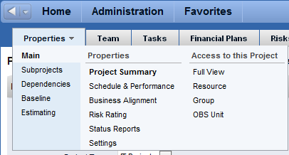

1. Click on “New”;

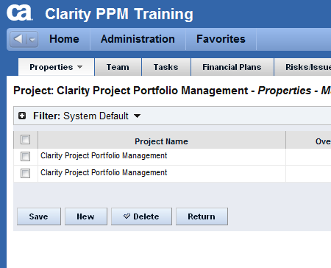

1. Complete the fields on the status report page;
2. Click on “Save” or “Save and Return” to save changes.
   * 1. Copying a Status Report
3. Open the project;
4. Select “Properties”, then “Status Reports”;
5. Click on “New”;
6. Complete the “Status Report Name” field;
7. Click on “Save”;
8. Selection “Actions” 🡪 “Copy”

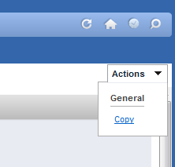

1. Select the status report to copy – See tip below to create permanent filter;

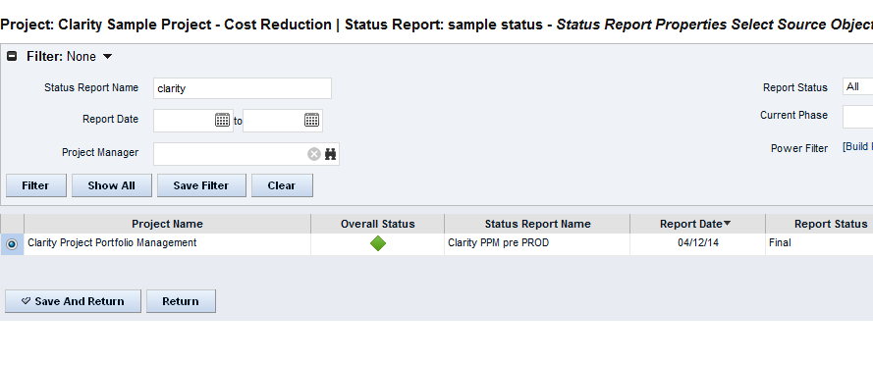

1. Update the required information;
2. Click on “Save” or “Save and Return” to save changes.
   * 1. Publishing a Status Report
3. Open the project;
4. Select “Properties”, then “Status Reports”;
5. Click on the Status Report Name to open the status report to be published;
6. Change the Report Status field to “Final”;

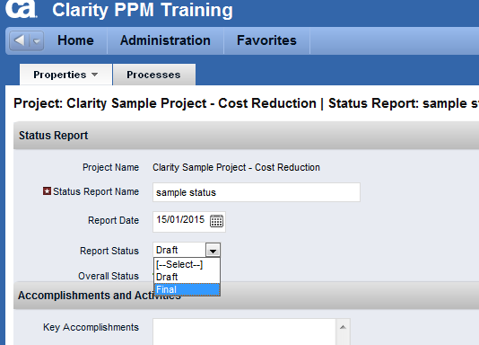

1. Save the changes.

**TIP:** By default, CA PPM displays all status reports when selecting a status report to copy. Filter the list of status reports to only display the ones on projects that you manage by doing the following:

1. Open the Copy action from a status report edit page;
2. Expand the filter by clicking on the + symbol;
3. Under the Project Manager filter, select your name;
4. Click on the Save Filter button;
5. Enter a descriptive name for the filter, i.e. My Reports;
6. Check the “Default” checkbox;
7. Click on “Save and Return”.

The Copy action will now automatically filter the available status reports to your status reports only.

* 1. Team Management

A project’s impact on the organization’s staff can be modeled using a top-down approach. Resources and roles can be added to a project and a high-level estimate of the hours required to complete the project can be allocated to the project.

**TIP:** A Resource is an actual person in the organization. A Role represents a type of resource in the organization. Hours allocated to a Role can be reassigned to a resource and vice-versa.

* + 1. Adding Resources to the Project

1. Open the project;
2. Click on the “Team” tab;
3. Click on the “Add” button;

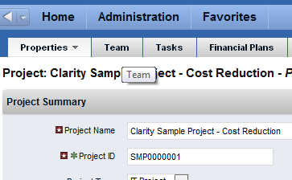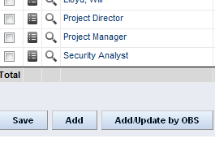

1. Search for the Resource or Role with the Filter options provided;
2. Select the resources you wish to add and click on “Add” to add them to the project team.

**TIP:** Resources and Roles are allocated at 0% for the duration of the project, by default.

**TIP:** Save commonly used filters to reuse filters.

**TIP:** Use the “Add and Select More” button to keep the resource finder window open.

* + 1. Allocating Hours to a Resource or Role

1. Open the project;
2. Click on the “Team” tab;
3. Click on the “Properties” icon ();

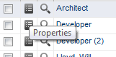

1. Set the Start and End Date for allocation period;
2. Set the allocation % for the resource;
3. Click on the “Save” button update the allocation;
4. To define a contour, use the Allocation table at the bottom screen;
5. Add rows to define the required allocation periods and percentages;
6. CA PPM will convert the allocation contour into an average allocation for the duration of the project;
7. Click on “Save” or “Save and Return” when the allocation is complete.

**TIP:** Keep the allocation to even percentages, no smaller than 10% (~1/2 day of effort)

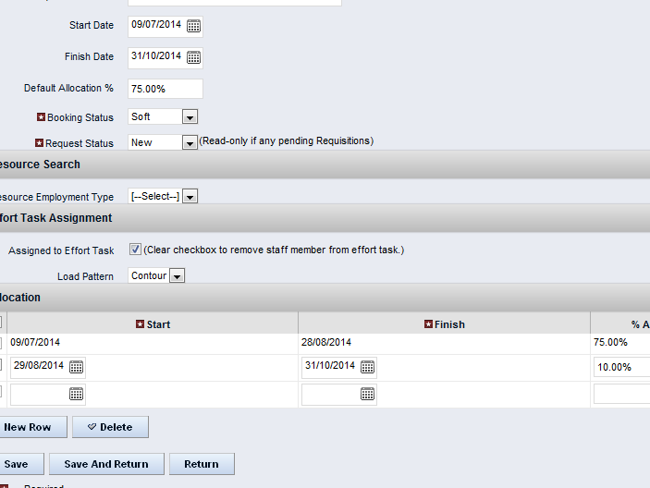

* 1. Managing Milestones (Optional)

Milestones can be added to a project in order to track key dates on a project.

* + 1. Creating a Milestone

1. Open the project;
2. Click on the “Tasks” tab;
3. Click on “New”;

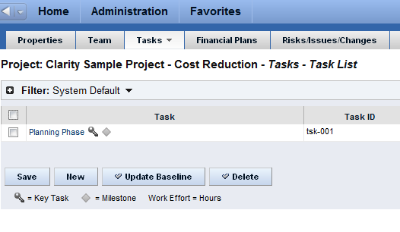

1. Provide a Task name, Start Date and Finish Date;
2. Ensure the “Key Task” and “Milestone” checkboxes are selected;
   1. Note that a Milestone will automatically set the Start Date equal to the Finish Date;
3. Click on “Save” or “Save and Return”.

**TIP:** Create multiple Milestones in succession by using the “Submit and Create New”.

**TIP:** Project Dates will automatically adjust to the dates of the tasks.

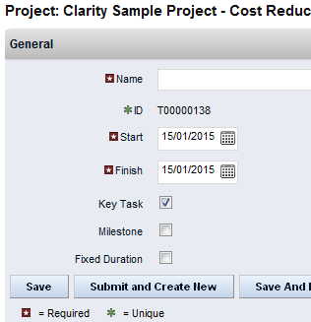

* + 1. Setting Key Task or Milestone Progress

1. Open the project;
2. Click on the “Tasks” tab;
3. The Task listing support inline editing;
   1. Edit the % Complete for each task;
   2. Edit the Start Date or Finish Date;
4. Click on “Save” to save the changes to the task(s).

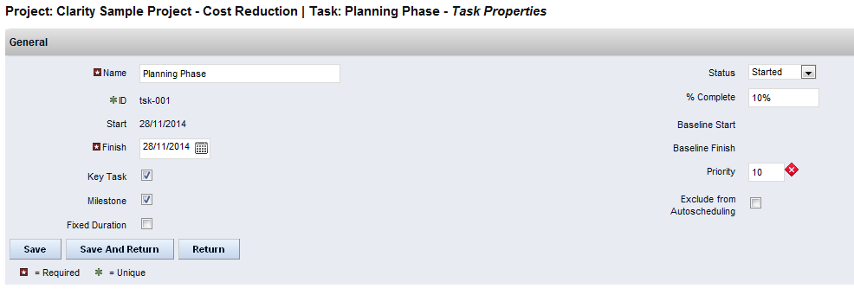

1. Project Risk, Issue, Change Request Management

CA PPM’s project risk, issue, change request management process includes identifying, analyzing, planning, tracking and communicating risks. The following diagram describes one way of managing project risks:

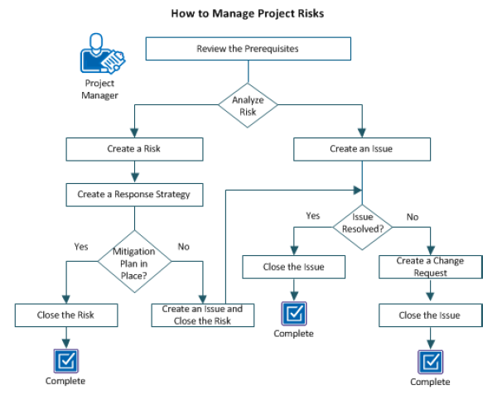

For more information about using CA PPM Risk Management process, please refer to the CA PPM Project Management User Guide.

* 1. Risk Management

CA PPM defines a risk as a potential future event that has a positive or negative impact on the project objective. Risks are ranked based on three criteria: a risk priority, risk probability and risk impact. A Risk Score is assigned to the risk based on the following matrix:

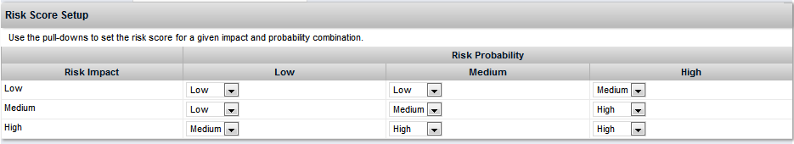

* + 1. Creating a New Risk

1. Open the project;
2. Click on the ”Risks/Issues/Changes” tab;
3. Click on “New”;

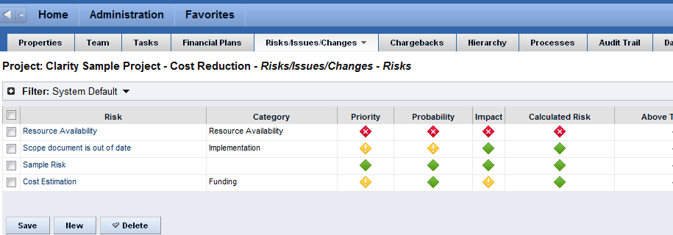

1. Complete the required information;
2. Click on “Save”;
3. Additional fields will be available once the risk is created.

**TIP:** Assigning a risk category will update the project’s overall risk assessment and make that category read-only on the Risk Rating page. Each open risk will contribute to the Risk Rating of the project.

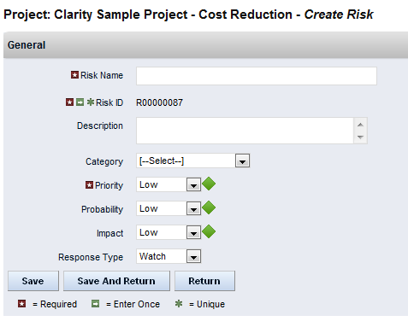

* + 1. Document a Risk Response

1. Open the project;
2. Click on the ”Risks/Issues/Changes” tab;
3. Open the risk by clicking on the Risk name;
4. Click the down arrow on the “Properties” tab;
5. Select Response Strategy;

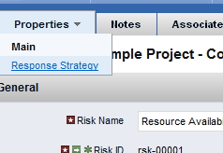

1. Add the response strategy in the space provided;
2. Assign the strategy to a project resource and set a resolution date;
3. Click on “Add” to document the Response Strategy.

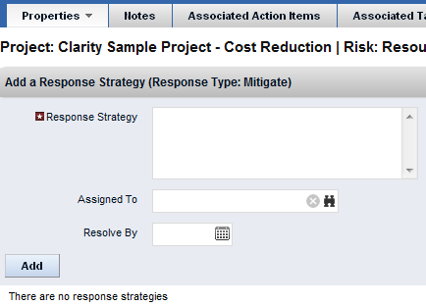

* 1. Issue Management

Issues can be created when a risk impacts a project in a significant way. Issues can be associated to a risk, task or action item to ensure that the issue is dealt with appropriately.

* + 1. Creating a New Issue

1. Open the project;
2. Click on the ”Risks/Issues/Changes” tab;
3. Click on the “Risks/Issues/Changes” tab again and select “Issues”;
4. Click on “New”;
5. Complete the required information;
6. Click on “Save”;
7. Additional fields will be available once the issue is created.

**TIP:** Impact Date and Target Resolution Date are key fields on an issue. CA PPM will highlight issues that remain open past the Target Resolution Date.

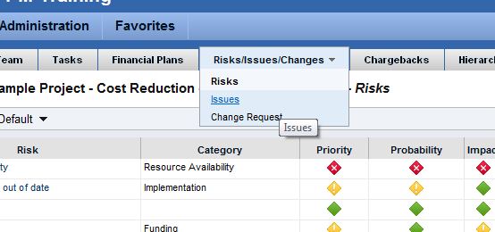

* + 1. Create an Issue from a Risk

1. Open the project;
2. Click on the ”Risks/Issues/Changes” tab;
3. Open the risk by clicking on the Risk name;
4. Click on “Create Issue” button;
5. Review the information entered and click on “Save” to create the issue;

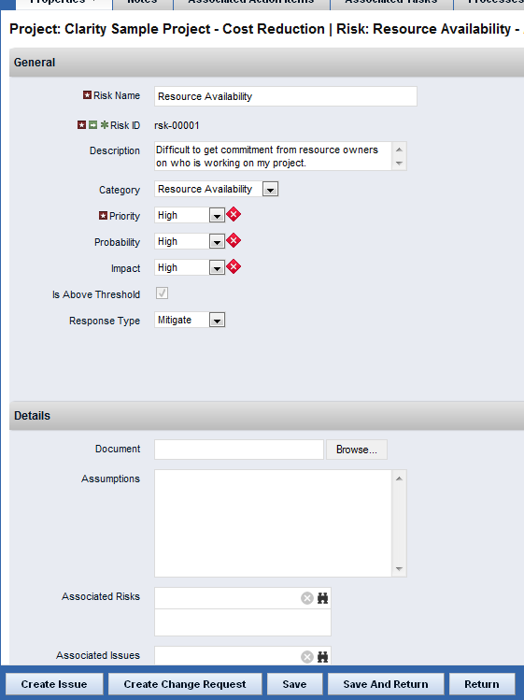

**TIP:** Note that the issue created from a Risk retains a link to the originating risk.

* 1. Change Request Management

A change request documents changes requested to the project’s scope.

* + 1. Creating a New Change Request

1. Open the project;
2. Click on the ”Risks/Issues/Changes” tab;
3. Click on the “Risks/Issues/Changes” tab again and select “Change Request”;

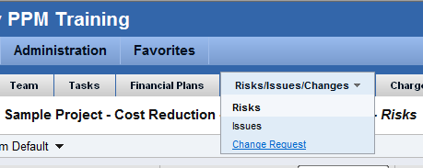

1. Click on “New”;

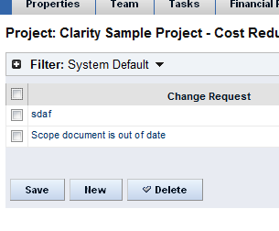

1. Complete the required information;
2. Click on “Save”;
3. Additional fields will be available once the change request is created.
4. Running Reports

Reports can be triggered for a specific project (where applicable) or for a group of projects. See Appendix 1 for a list of the available reports.

* 1. Running a Report on a Project Instance

1. Open the project;
2. On the project properties page, click on Actions;
3. Select the report to run (note that not all reports are available from this menu).

**TIP:** Avoid clicking on the report name multiple times or multiple instances of a report may be triggered.

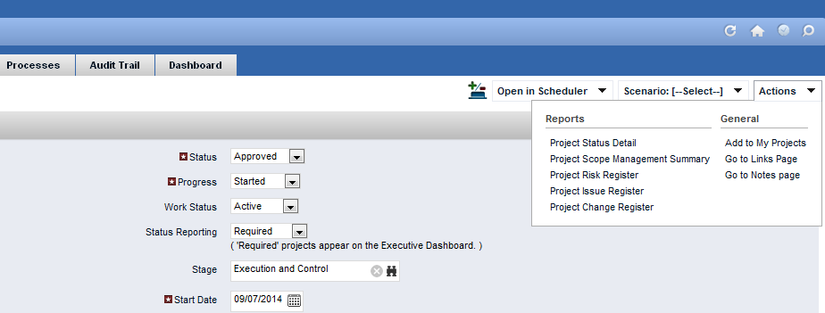

* 1. Running a Report

1. Click on the “Home” menu;
2. Select “Reports and Jobs”;

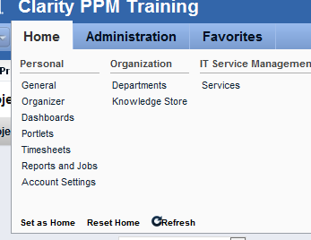

1. Click on the report name that you wish to run;
2. Complete the report’s parameters and click on Submit;

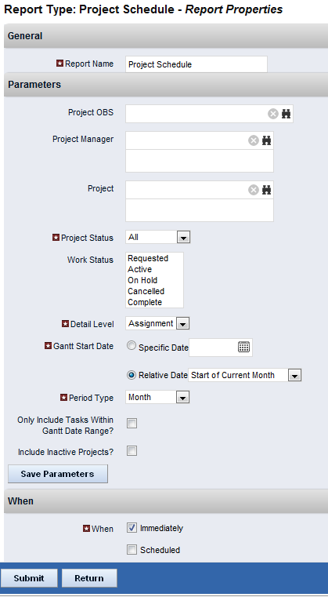

1. The report will appear in a new window.

**TIP:** Parameters for a report can be saved for future use. The saved parameters will appear in the report list as a separate report under the report type.

**TIP:** Parameters for a report can be saved for future use. The saved parameters will appear in the report list as a separate report under the report type.

1. Available Reports
   1. KPIs by Project Type



The KPIs by Project Type report lists projects, grouped by project type. It displays the key performance indicators of status, schedule, alignment, and risk along with resource allocation and actual hours from the inception of the project.

* 1. Project Change Request Register



The Project Change Request Register report displays comprehensive information for each project change request. The change request register also provides the option to display associated notes. The report may be grouped by project or not grouped.

* 1. Project Issue Register



The Project Issue Register report displays comprehensive information for each project issue. The issue register also provides the option to display items associated to the issue such as notes, action items, and tasks. The report may be grouped by project or not grouped.

* 1. Project List



The Project List report displays general information about the project such as manager, schedule dates, status, and business owner. The report may be grouped by several different options including: Portfolio Category, Project Type, Project Status, Work Status, Stage, Project Manager, Business Owner, and OBS Level. The columns that display in the report change based on the grouping option selected.

* 1. Project Risk, Issue, and Change Summary



The Project Risk, Issue, and Change Summary report includes two sets of pie charts. The first set displays the number of risk and issues by target resolution date and the number of change requests by expected close date. The second set displays the number of risks, issues and change requests by status. The report also includes a detail listing of risks, issues, and change requests with the following information: name, ID, priority, status, category, owner, created date, and target resolution or expected close date. The report detail may be grouped by project or not grouped.



The second section of the report provides a one page view of the risks, issues and change requests grouped by project.

* 1. Project Risk Register



The Project Risk Register report displays comprehensive information for each project risk. The risk register also provides the option to display items associated to the risk such as notes, action items, tasks, and other risks and issues. The report may be grouped by project or not grouped.

* 1. Project Status Detail



The Project Status Detail report displays detailed information about the project team allocations, key milestones, risks, issues and change requests, including the most relevant project indicators.

* 1. Project Status Report List



The Project Status Report List report displays schedule dates, work status, and status report indicators across projects. The report may be grouped by several different options including: Portfolio Category, Overall Status, Project Type, Stage, Project Manager, Business Owner, and OBS Level. The columns that display in the report change based on the grouping option selected. The overall status summary pie chart displays the percentage of projects with each overall status color. The column chart displays the number of projects for each overall status color and is grouped by the option selected when running the report.

* 1. Project Status Summary



The Project Status Summary report displays summary information about a project, including current stage, overall status, key accomplishments, upcoming activities, the cost and amount of resources consumed, mapped risks indicating categories with high number of risks, and a high level Gantt chart displaying information about the project phases and key milestones.

* 1. Project Storyboard



The Project Storyboard report shows key aspects of a project organized in separate frames. Each frame in the report displays project information such as project dates, project objective, the amount and cost of resources planned and actual, key accomplishments, upcoming activities, current issues and risks, and the project progress towards goals. This report can be used to analyze the project earned value and track work performance to account for cost and schedule variances.